- What educational toys do kids actually enjoy playing with?
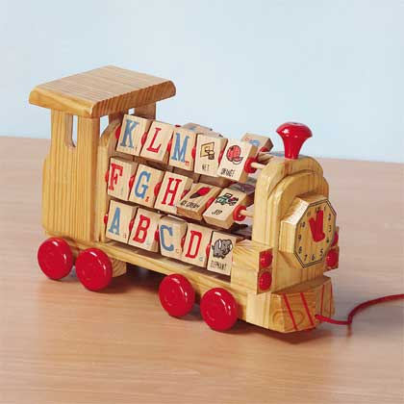
Oh lots. Children can make toys out of anything. Anything that helps them use their imagination is good. Most enjoy "hands on" so dress up, animals, kitchen play, dolls, cars and trucks, musical instruments, books, train sets, etc. You name it. As children grow older their tastes change of course. But like I said, anything that helps them develop their imagination and stretch their minds is great. Remember, children are individual. What one child grabs onto, another may not be too interested. But if you watch their tastes and what they like to do, you will know what they might enjoy. A toddler may like a ball, or a push toy, a 3 year old may like to play with dolls, or cars, a 5 year old may like something a little more challenging.

- Would paintball guns be good toys for pre-teen and teen age kids?
Paintball guns can be fun and educational, but require a certain degree of maturity to use properly. There are the traditional issues related to gun safety, especially how to avoid accidental weapon discharge in "safe" areas. Then there are special issues for paintball, like proper use of face protectors.
Contrary to popular belief, paintballs do NOT hurt as badly as you think.... so long as the gun's muzzle velocity doesn't exceed the 250-300 FPS limit that most courses mandate and the firer is a reasonable distance away. Common etiquette around here is that within about eight feet or so, you hold fire and give your opponent the chance to surrender. At closer ranges, it could hurt enough that any honorable, right-minded player will usually concede defeat rather than risk a bruise. At longer ranges, the ball has slowed enough to not pose much risk of pain.
I have taken many hits to the torso in nothing but a t-shirt and been shot in the bare hand a few times with no more than a sting that went away within a few minutes. I have been hit in parts of my head not covered by the (mandatory) facemask/goggle I was wearing and shaken it off.
Good paintball equipment is a little pricey for a hobby, especially when you add in the cost of protective equipment, air tank refills, and paintballs. Any decent gun worth having will run at least $150... used
Before you make the investment, ask yourself, "Is this child is mature enough to be trusted to ...

- How did the bear become a favoured toy for children when it is actually a dangerous animal?
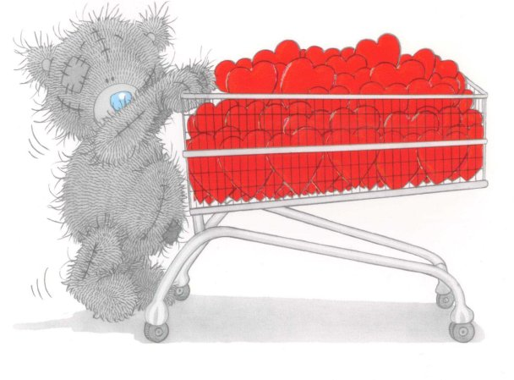
"Morris and Rose Mitchom, owners of a Brooklyn candy store in 1902, take credit for creating the first Teddy Bear in the United States after the incident described below and after seeing Berrymans cartoon.
"On the 14 November 1902, Theodore Roosevelt, the 26th President of the United States of America took time out for relaxation after some hard political bargaining over the disputed boundaries between the states of Mississippi and Louisiana. His hosts took him on a hunting trip to an area near Little Sunflower River in Mississippi. In an effort to please the President a bear cub was captured, stunned and tied to a tree to ensure that the President had an easy target and would go home with a trophy.
"However this plan backfired because the President refused to shoot the defenceless cub and ordered it to be set free. The press who were covering Roosevelt's visit quickly heard of the incident and the Washington Star's political cartoonist Clifford Berryman drew this cartoon of the incident entitled 'Drawing the line at Mississippi. The cartoon emphasises the child like helplessness of the cub and was designed to convey the politiacl message that such an upstanding President as Roosevelt could not be persuaded to make decisions for the wrong reasons. The cartoon was printed in all the papers and Roosevelt's popularity soared as a result of his actions. For the rest of his political career Roosevelt mascot was 'Teddy's Bear'...

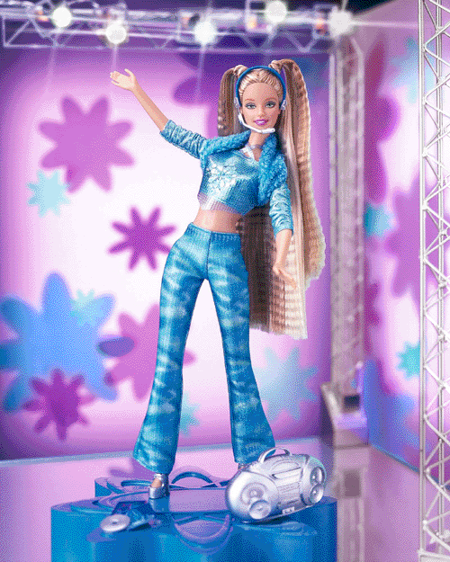
- How did the Barbie doll get its name?
Ruth Handler (co-founder of Mattel, the company that marketed and manufactured Barbie dolls) had noted that her daughter Barbara preferred playing with paper dolls that looked like adults rather than like children. When in Europe, she noticed a German doll named Lilli and bought it for Barbara.
Ruth Handler and Elliott Handler, the co-founders of Mattel, bought the rights to market Lilli: with a hair color change from blonde to brunette, and a name change to Barbie (after Ruth's daughter Barbara) she was sold in the United States starting in 1959 at New York's annual Toy Fair.

